Hands-on Exercise No. 1 , DigiSkills 3 .0 Batch-04

Data Analytics and Business Intelligence
Tasks: 1
Use the SUMIFS function to calculate the total Sales for orders where the Category is "Technology", and the Region is "West".
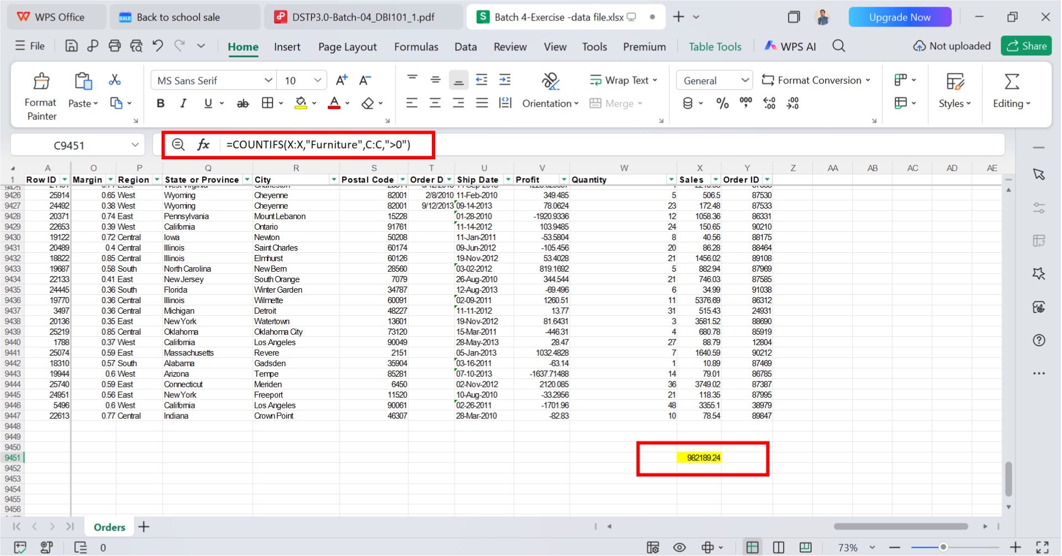
Screenshot:

Tasks: 2
Use the COUNTIFS function to determine the number of orders that belong to the Furniture category and have a Discount greater than 0.
Screenshot:
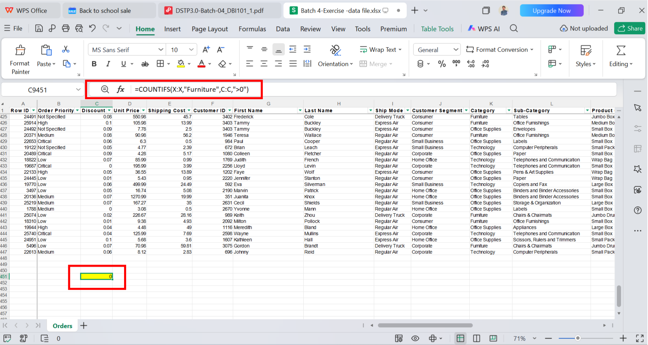
s
Tasks: 3
Use Conditional Formatting on the Profit column to highlight values greater than 0 in green and the values less than 0 in r ed.
Screenshot:
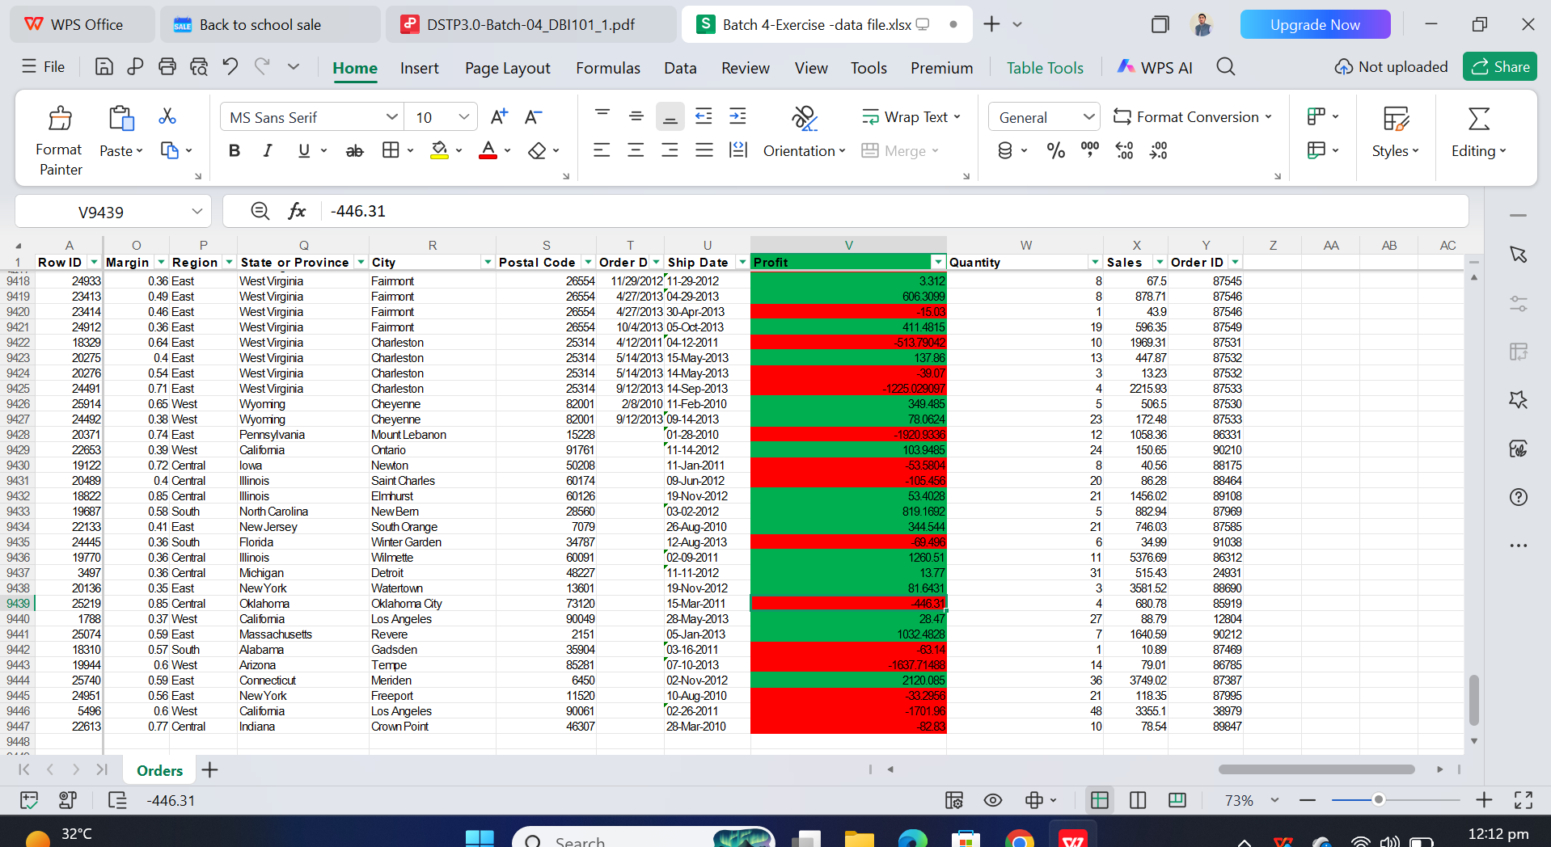
Tasks: 4
Create a Pivot Table to summarize the total Sales by Category and identify which category generated the highest sales.
Screenshot:
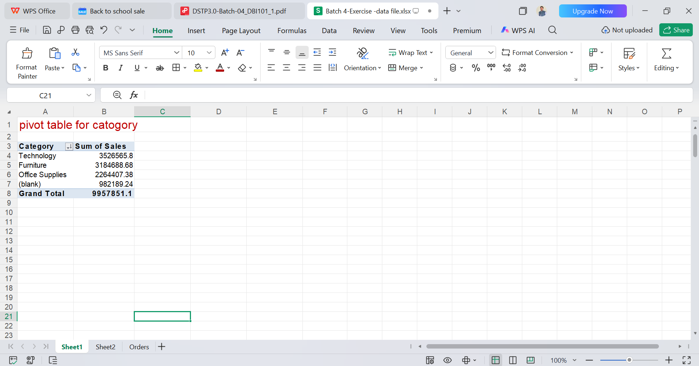

Tasks: 5
Create a Pivot Table to summarize the total Profit by Region and identify which region earned the highest profit.
Screenshot:
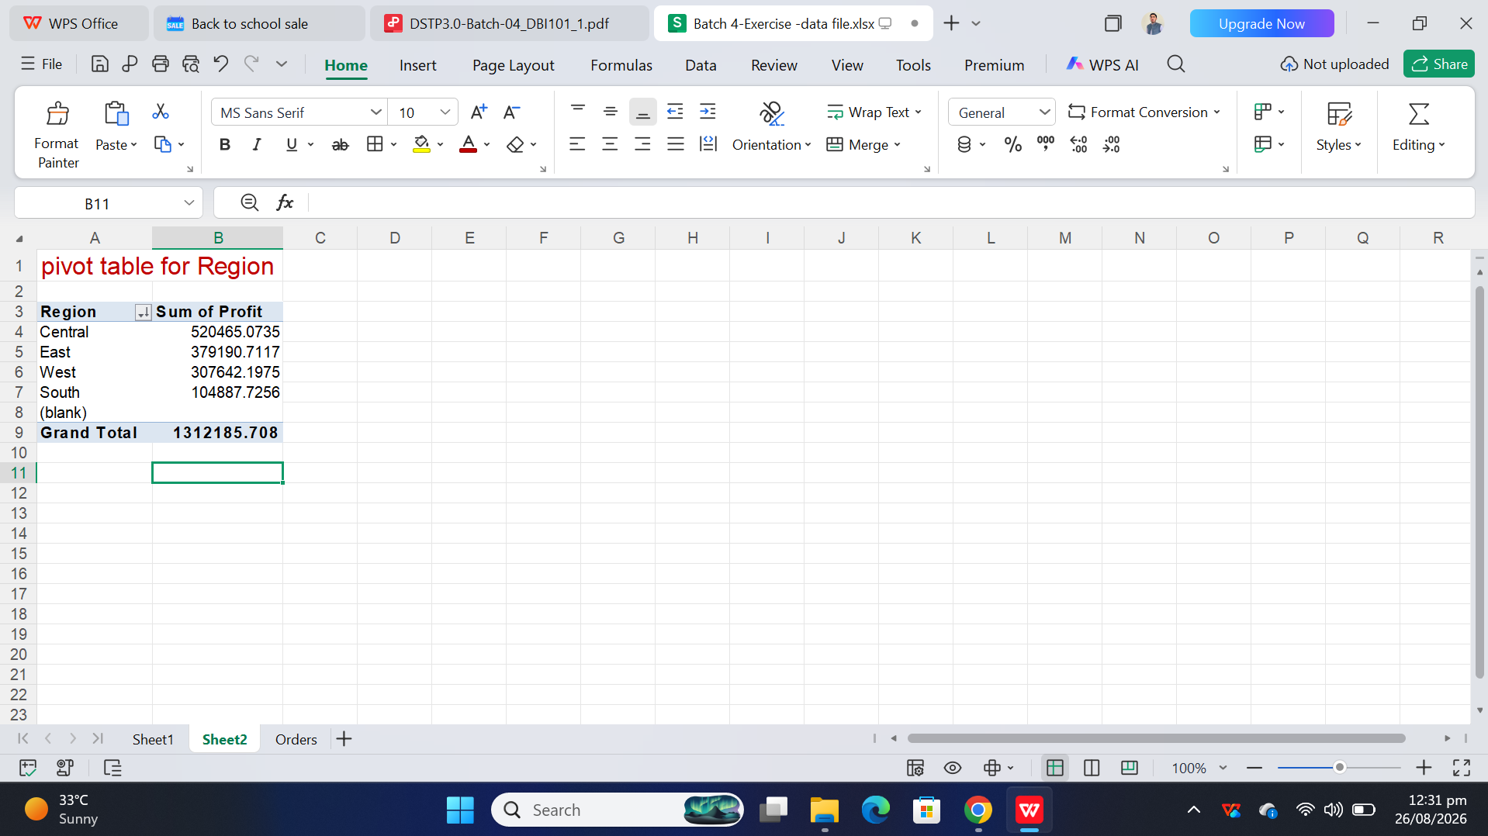

Thanks

